Randomness and Sensing - Part I
Lizard Wizard Enemy Spider

NPC
Enemy Spider

States
• Idle
• Pounce
• Retreat

Sense
Vision
Feeling

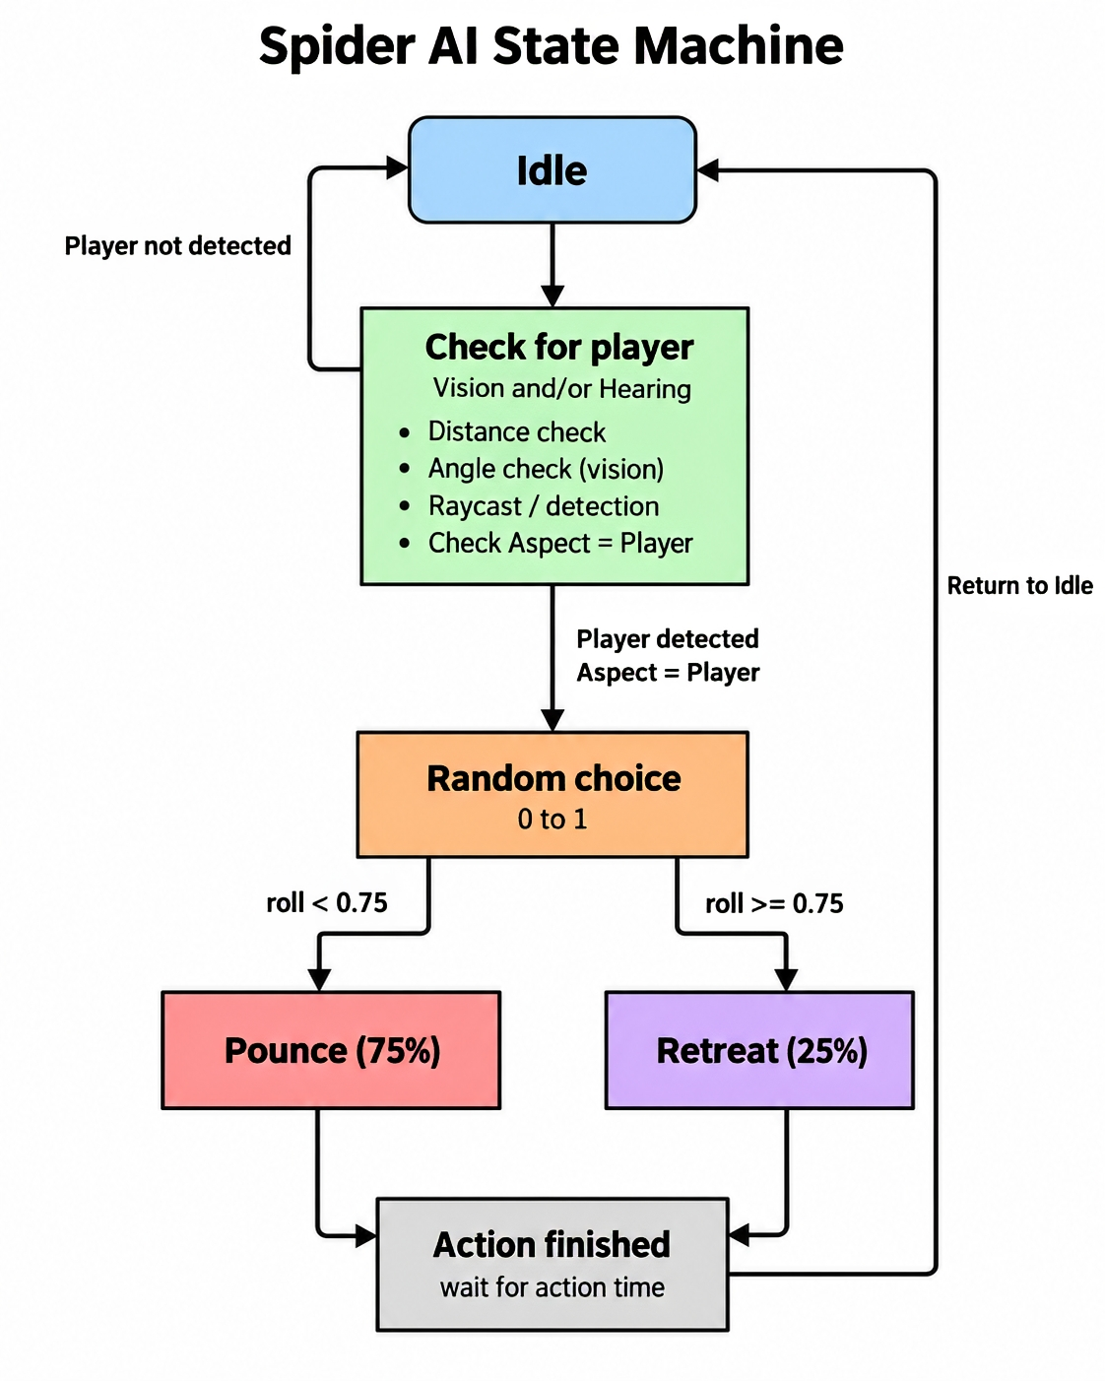

How It Works
The spider starts in Idle. It checks for the player using vision. To keep it simple and efficient, it first checks if the player is close enough and in front of the spider. If both are true, it uses a raycast to check if there is a clear line of sight.

If the player is not seen, the spider stays in Idle.

If the player is seen, it makes one random choice:
• 75% chance - Pounce
• 25% chance - Retreat

The random choice only happens once when the player is detected, so the spider does not keep switching states every frame.

State Machine Outline
Idle
→ Check distance
→ Check view angle
→ Raycast
→ Player detected
→ Random choice
→ 75% Pounce / 25% Retreat
→ Action finishes
→ Retreat if player is dead or if player escapes proximity
→ Return to Idle

Performance / Optimization
• Check distance and view angle before using a raycast.
• Do not check vision every frame. Check a few times per second.
• Only make the random choice once when the player is detected.
• Keep the state machine small with only three states.

Spider has 3 states
- Idle
- Pounce
- Retreat
Spider Can detect the player though
- Vision
- Hearing

Either sense triggers the same random reaction:
- 75% Pounce
- 25% Retreat

Shared Connection:
Vision detects player → ChooseReaction()
Hearing detects noise → ChooseReaction()
Vision + FSM
- Create the 3 states
- Make the state switching
- Add the 75/25 randomness choice
- Add vision
  - Distance check
  - View angle
  - Raycast
- Return to idle after pounce or retreat (for the sake of time, just debug)
- Print states to Console
Hearing
- Add the hearing range
- Treat it like a sphere around the spider - sphere collider
- Make a simple noise event from the player
- If the noise happens inside the hearing range, tell the spider the player was detected
- Add Gizmos DrawWireSphere so the hearing range is visible

Then we connect both the parts to the same method

Pseudo code
Vision + FSM
Start in Idle
While in Idle:
Check if player is close enough
Check if player is in front
If both are true
Raycast toward player
If raycast sees player:
Choose reaction

Choose reaction:
Generate random number
If number < 0.75:
Change to Pounce
Else:
Change to Retreat

Pounce:
Move toward player
When finished:
Return to Idle
Retreat:
Move away from player
When finished:
Return to Idle

Hearing:
Create hearing radius around spider
When player makes noise:
Check if player is inside hearing radius
If player is inside radius:
Spider hears noise
Call ChooseReaction()

